Bank Account GUI Project

A Welcome Panel:

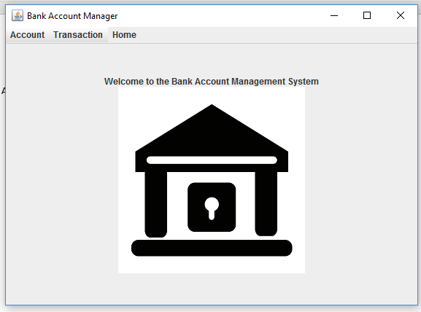

JMenu:

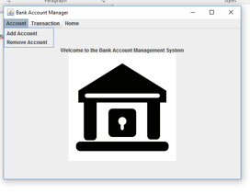

Accounts tab should have options to Create Account, Remove Account, Find Accounts

Transactions Should have an option to Deposit, Withdraw, Transfer, or Get Balance.

There should be a way to return to the home Screen

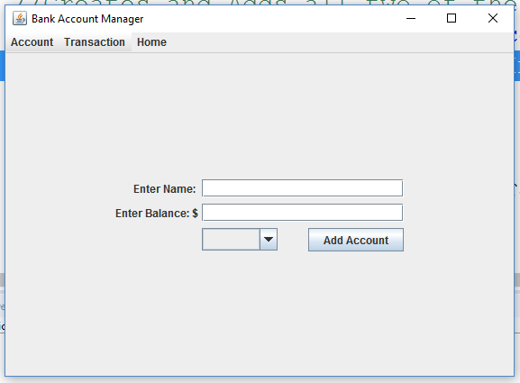

You Can create your project however you envision it. You may create separate panels for deposit/withdraw or you may create ways to use the same frame and give options using a check box. I simply want to see a project that you feel you have created. It should be a functioning program which would appear to be one that a teller could use at a bank.